Online Supporting Information to

“The Dynamics of Message Selection in Online Political Discussion Forums”

**Contents**

**Inclusion of the control terms in the TERGM model** 1

Table S1. Full TERGM results including model building procedures 2

Table S2. Full TERGM results including interactions 4

Figure S1. The Goodness-of-fit (*gof*) assessment of final model specification 6

Table S3. Model robustness checks 7

Figure S2. Parameter estimates and 95% confidence intervals from the final model 9

Figure S2. Parameter estimates and 95% confidence intervals from the final model (con’d) 10

Table S4. Additional robustness checks 11

# **Inclusion of the control terms in the TERGM model**

All models reported in Table 2 of the main document control for age, gender (including homophily), education, regional origins (including homophily), offline talk frequency, media use frequency, internal discussion efficacy, candidate preference, hedonic motivations, activity spread (gw-outdegree), isolate, and multiple two-paths (gwdsp), as well as lagged versions of network-endogenous statistics (previous communication, delayed reciprocity, delayed transitivity, delayed cyclic closure, delayed activity closure, delayed popularity closure, and number of in- and out ties of a given nodes at previous time point). Here, we control for (a) all possible temporal dependencies in a form of lagged structural variables (which closely resemble the concurrent structural terms), and (b) other covariates that help control lower-order effects in estimating higher-order effect (e.g., GWDSP), and (c) control for basic degree effects and densities (edge and isolate parameter together, given non-negligible number of isolates in each time period).

# **Table S1. Full TERGM results including model building procedures**

|  |  |  |  |
| --- | --- | --- | --- |
|  | **Control only** | **Control + Structural** | **Final Model** |
| Edges (Intercept) | **-4.977** [-6.749; -6.749]* | **-1.127** [-2.206; -2.206]* | **-1.890** [-2.932; -1.392]* |
| ***Motivation and Homophily*** |  |  |  |
| Consistency motivation (in-ties) |  |  | **.034** [.009; .113]* |
| Consistency motivation (out-ties) |  |  | .025 [-.044; .077] |
| Understanding motivation (in-ties) |  |  | -.052 [-.080; .022] |
| Understanding motivation (out-ties) |  |  | **.028** [.005; .076]* |
| Hedonic motivation (in-ties) |  |  | -.012 [-.029; .001] |
| Hedonic motivation (out-ties) |  |  | **.102** [.087; .133]* |
| Same candidate preference |  |  | -.032 [-.070; .047] |
| Similar policy preference |  |  | -.108 [-.212; .006] |
| Similar evaluative criteria |  |  | **.407** [.399; .415]* |
| ***Endogenous structural effects*** |  |  |  |
| Isolates |  | **1.021** [.797; .797]* | **1.019** [.908; 1.264]* |
| Reciprocity |  | **.765** [.497; .497]* | **.769** [.564; 1.068]* |
| Multiple path closure (GWESP-OTP) |  | **.058** [-.056; -.056]* | .058 [-.053; .125] |
| Multiple cyclic closure (GWESP-ITP) |  | **-.068** [-.082; -.082]* | **-.066** [-.080; -.060]* |
| Multiple activity closure (GWESP-OSP) |  | **.035** [.030; .030]* | **.036** [.033; .045]* |
| Multiple popularity closure (GWESP-ISP) |  | **.117** [.083; .083]* | **.115** [.093; .232]* |
| Multiple two-paths (GWDSP) |  | **.003** [-.005; -.005]* | .003 [-.007; .007] |
| Activity spread (GW-outdegree) |  | **-4.399** [-4.669; -4.669]* | **-4.350** [-4.557; -4.157]* |
| Popularity spread (GW-indegree) |  | **-4.056** [-5.343; -5.343]* | **-4.049** [-5.342; -3.259]* |
| ***Lagged structural effects*** |  |  |  |
| Previous communication |  | **.214** [.182; .182]* | **.222** [.192; .253]* |
| Delayed reciprocity |  | **.082** [-.067; -.067]* | .074 [-.073; .194] |
| Delayed transitivity closure |  | **.034** [.018; .018]* | **.034** [.020; .055]* |
| Delayed cyclic closure |  | **.037** [.010; .010]* | **.034** [.008; .057]* |
| Delayed activity closure |  | **-.058** [-.068; -.068]* | **-.056** [-.067; -.046]* |
| Delayed popularity closure |  | **-.060** [-.089; -.089]* | **-.059** [-.110; -.043]* |
| Persistent sender (out-tie) |  | **.019** [.009; .009]* | **.019** [.010; .029]* |
| Persistent receiver (in-ties) |  | **.023** [.019; .019]* | **.023** [.018; .038]* |
| ***Controls*** |  |  |  |
| Age (in-ties) | **.101** [-.012; -.012]* | **.003** [-.017; -.017]* | .001 [-.020; .022] |
| Age (out-ties) | **.218** [-.097; -.097]* | **.031** [-.224; -.224]* | .052 [-.105; .093] |
| Female (in-ties) | **-.204** [-.245; -.245]* | **-.001** [-.038; -.038]* | .005 [-.036; .041] |
| Female (out-ties) | **-.169** [-.446; -.446]* | **.075** [-.308; -.308]* | .014 [-.348; .254] |
| Gender homophily | **.010** [-.032; -.032]* | **.051** [.018; .018]* | **.044** [.023; .086]* |
| Education (in-ties) | **-.114** [-.182; -.182]* | **-.008** [-.042; -.042]* | -.011 [-.039; .019] |
| Education (out-ties) | **-.132** [-.239; -.239]* | **.028** [-.010; -.010]* | .016 [-.015; .091] |
| Regional origin = Seoul (in-ties) | **-.418** [-.501; -.501]* | **-.077** [-.116; -.116]* | -.084 [-.130; .044] |
| Regional origin = Seoul (out-ties) | **-.192** [-.383; -.383]* | **-.143** [-.635; -.635]* | -.125 [-.438; .350] |
| Regional homophily (Seoul) | **-.021** [-.047; -.047]* | **.013** [-.020; -.020]* | .017 [-.014; .080] |
| Offline talk frequency (in-ties) | **.129** [-.120; -.120]* | **.045** [.021; .021]* | **.046** [.024; .049]* |
| Offline talk frequency (out-ties) | **.025** [-.428; -.428]* | **.034** [-.173; -.173]* | .014 [-.099; .161] |
| Media use (in-ties) | **-.061** [-.108; -.108]* | **-.011** [-.021; -.021]* | **-.011** [-.019; -.003]* |
| Media use (out-ties) | **-.070** [-.104; -.104]* | **.040** [.004; .004]* | .033 [-.017; .071] |
| Internal efficacy (in-ties) | **.051** [-.045; -.045]* | **-.013** [-.040; -.040]* | -.013 [-.058; .055] |
| Internal efficacy (out-ties) | **.187** [.132; .132]* | **-.018** [-.098; -.098]* | .024 [-.102; .128] |
| Candidate preference = Moon (in-ties) | **.174** [.057; .057]* | **-.018** [-.063; -.063]* | .003 [-.008; .092] |
| Candidate preference = Moon (out-ties) | **.315** [.216; .216]* | **-.010** [-.100; -.100]* | .013 [-.123; .066] |
| Num. obs. | 291096 | 291096 | 291096 |
| * = zero outside the 95% bias-corrected and accelerated confidence interval based on 1000 replications.  Note: Decay (alpha) values for each geometrically weighted term are: GWESP-OTP = 3, GWESP-ITP = 3, GWESP-OSP = 3, GWESP-ISP = 2, GWDSP = 1, GW-outdegree = 2, and GW-indegree = 3. “Final model” denotes the final model reported in the Table 2 in the main manuscript. | | | |

# **Table S2. Full TERGM results including interactions**

|  |  |  |  |
| --- | --- | --- | --- |
|  | **Interaction I** | **Interaction II** | **Interaction III** |
| Edges (Intercept) | **-1.819** [-2.732; -.304]* | **-1.823** [-2.807; -1.169]* | **-1.936** [-2.937; -1.098]* |
| ***Motivation and Homophily*** |  |  |  |
| Consistency motivation (in-ties) | .037 [-.004; .113] | **.037** [.010; .113]* | **.037** [.010; .113]* |
| Consistency motivation (out-ties) | .019 [-.112; .071] | .019 [-.112; .071] | .019 [-.043; .071] |
| Understanding motivation (in-ties) | -.049 [-.103; .022] | -.049 [-.103; .022] | -.049 [-.078; .022] |
| Understanding motivation (out-ties) | **.036** [.012; .075]* | **.035** [.011; .087]* | **.035** [.011; .075]* |
| Hedonic motivation (in-ties) | -.012 [-.038; .001] | -.013 [-.032; .001] | -.013 [-.038; .001] |
| Hedonic motivation (out-ties) | **.102** [.094; .130]* | **.102** [.096; .130]* | **.102** [.094; .105]* |
| Same candidate preference | **-.135** [-.211; -.111]* | -.033 [-.079; .047] | -.032 [-.079; .047] |
| Similar policy preference | -.091 [-.225; .042] | -.090 [-.230; .042] | .094 [-.764; .272] |
| Similar evaluative criteria | **.385** [.260; .404]* | .295 [-.359; .639] | **.389** [.255; .405]* |
| ***Interaction effects*** |  |  |  |
| Time trends (linear) | .079 [-.059; .262] | **.083** [.021; .171]* | **.144** [.063; .235]* |
| xSame candidate preference | **.051** [.038; .071]* |  |  |
| xSimilar evaluative criteria |  | .046 [-.176; .242] |  |
| xSimilar policy preference |  |  | -.095 [-.253; .214] |
| ***Endogenous structural effects*** |  |  |  |
| Isolates | **1.003** [.793; 1.264]* | **1.005** [.793; 1.152]* | **1.005** [.895; 1.264]* |
| Reciprocity | **.768** [.560; 1.068]* | **.768** [.559; 1.068]* | **.768** [.507; 1.068]* |
| Multiple path closure (GWESP-OTP) | .057 [-.053; .094] | .057 [-.053; .125] | **.057** [.025; .125]* |
| Multiple cyclic closure (GWESP-ITP) | **-.066** [-.076; -.061]* | **-.066** [-.076; -.061]* | **-.066** [-.080; -.061]* |
| Multiple activity closure (GWESP-OSP) | **.035** [.033; .043]* | **.035** [.033; .041]* | **.035** [.033; .043]* |
| Multiple popularity closure (GWESP-ISP) | **.113** [.083; .232]* | **.113** [.083; .232]* | **.113** [.098; .232]* |
| Multiple two-paths (GWDSP) | .003 [-.007; .007] | .003 [-.007; .007] | .003 [-.007; .009] |
| Activity spread (GW-outdegree) | **-4.395** [-4.557; -4.153]* | **-4.392** [-4.557; -4.152]* | **-4.392** [-4.557; -3.994]* |
| Popularity spread (GW-indegree) | **-4.123** [-5.342; -3.541]* | **-4.120** [-5.342; -3.537]* | **-4.121** [-4.810; -3.259]* |
| ***Lagged structural effects*** |  |  |  |
| Previous communication | **.220** [.184; .250]* | **.220** [.184; .250]* | **.219** [.185; .250]* |
| Delayed reciprocity | .076 [-.073; .289] | .075 [-.073; .257] | .076 [-.073; .257] |
| Delayed transitivity closure | **.033** [.019; .051]* | **.033** [.019; .051]* | **.033** [.019; .051]* |
| Delayed cyclic closure | **.032** [.008; .041]* | **.032** [.008; .057]* | **.032** [.008; .043]* |
| Delayed activity closure | **-.055** [-.060; -.035]* | **-.055** [-.065; -.035]* | **-.055** [-.065; -.035]* |
| Delayed popularity closure | **-.058** [-.081; -.034]* | **-.058** [-.110; -.043]* | **-.058** [-.081; -.034]* |
| Persistent sender (out-tie) | **.019** [.010; .029]* | **.019** [.010; .025]* | **.019** [.010; .025]* |
| Persistent receiver (in-ties) | **.023** [.018; .038]* | **.023** [.018; .038]* | **.023** [.021; .038]* |
| ***Controls*** |  |  |  |
| Age (in-ties) | -.003 [-.023; .020] | -.003 [-.022; .035] | -.003 [-.022; .020] |
| Age (out-ties) | .040 [-.192; .091] | .040 [-.112; .090] | .040 [-.113; .090] |
| Female (in-ties) | .009 [-.037; .043] | .009 [-.036; .071] | .009 [-.036; .071] |
| Female (out-ties) | .029 [-.348; .268] | .029 [-.348; .268] | .029 [-.348; .335] |
| Gender homophily | **.044** [.015; .070]* | **.044** [.015; .086]* | **.044** [.022; .086]* |
| Education (in-ties) | -.010 [-.029; .019] | -.010 [-.029; .019] | -.010 [-.029; .018] |
| Education (out-ties) | .015 [-.016; .073] | .015 [-.016; .072] | .015 [-.016; .071] |
| Regional origin = Seoul (in-ties) | -.083 [-.157; .044] | -.084 [-.131; .044] | **-.084** [-.157; -.031]* |
| Regional origin = Seoul (out-ties) | -.143 [-.598; .350] | -.142 [-.450; .350] | -.143 [-.449; .350] |
| Regional homophily (Seoul) | .015 [-.014; .048] | .015 [-.014; .080] | .015 [-.014; .080] |
| Talk freq (in-ties) | **.030** [.018; .037]* | **.030** [.018; .036]* | **.030** [.002; .037]* |
| Talk freq (out-ties) | -.005 [-.097; .161] | -.006 [-.130; .161] | -.006 [-.143; .110] |
| Media use (in-ties) | **-.018** [-.024; -.002]* | **-.018** [-.024; -.002]* | -.018 [-.024; .000] |
| Media use (out-ties) | **.024** [.001; .287]* | .024 [-.017; .075] | .024 [-.017; .074] |
| Internal efficacy (in-ties) | -.012 [-.058; .055] | -.012 [-.058; .055] | -.012 [-.042; .055] |
| Internal efficacy (out-ties) | .030 [-.102; .128] | .031 [-.064; .128] | .031 [-.102; .128] |
| Candidate pref = Moon (in-ties) | .006 [-.008; .049] | .004 [-.008; .092] | .003 [-.008; .092] |
| Candidate pref = Moon (out-ties) | .017 [-.123; .070] | .017 [-.123; .070] | .016 [-.063; .131] |
| Num. obs. | 291096 | 291096 | 291096 |
| * = zero outside the 95% bias-corrected and accelerated confidence interval based on 1000 replications.  Note: Decay (alpha) values for each geometrically weighted term are: GWESP-OTP = 3, GWESP-ITP = 3, GWESP-OSP = 3, GWESP-ISP = 2, GWDSP = 1, GW-outdegree = 2, and GW-indegree = 3. | | | |

# **Figure S1. The Goodness-of-fit (*gof*) assessment of final model specification**

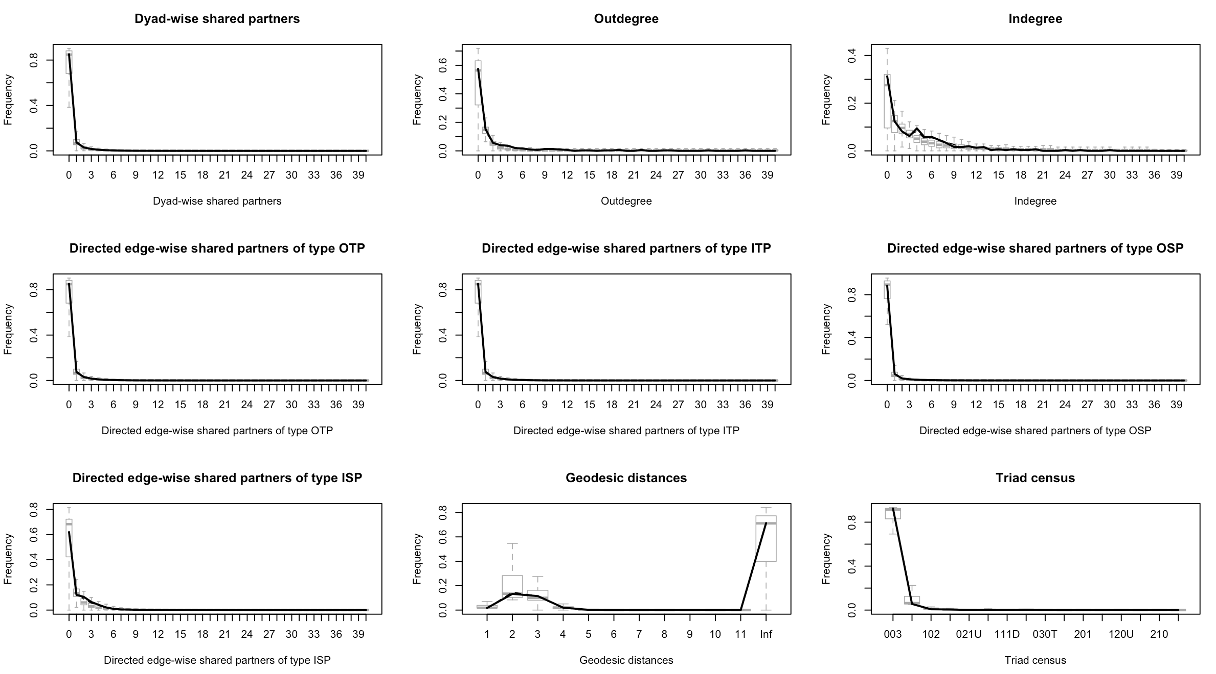

Note: The distribution of network statistics from the simulated networks (N = 900) does not significantly deviate from that of the observed statistic (bold line), suggesting that model fit is acceptable and adequate.

# **Table S3. Model robustness checks**

|  |  |  |  |  |  |
| --- | --- | --- | --- | --- | --- |
|  | **Final model** | **Multiple Imputation** | **Daily** | **No Threshold** | **MRQAP** |
| Edges (Intercept) | -**1.89** [-2.93; -1.39]* | **-1.19** [-3.29; -.58]* | **-1.24** [-1.80; -.64]* | **-.29** [-.37; -.25]* | 1.209 |
| Age (in-ties) | .001 [-.020; .022] | .002 [-.003; .026] | **-.022** [-.036; -.009]* | **-.015** [-.041; -.004]* | .049 |
| Age (out-ties) | .052 [-.105; .093] | .069 [-.193; .120] | .029 [-.002; .064] | **.038** [.008; .052]* | **.307**\*\*\* |
| Female (in-ties) | .005 [-.036; .041] | .022 [-.005; .070] | **-.037** [-.062; -.001]* | .009 [-.017; .042] | -.103 |
| Female (out-ties) | .014 [-.348; .254] | .055 [-.269; .282] | **-.043** [-.105; -.003]* | -.005 [-.084; .042] | .037 |
| Gender homophily | **.044** [.023; .086]* | **.069** [.043; .101]* | .018 [-.003; .041] | .016 [-.011; .034] | .055 |
| Education (in-ties) | -.011 [-.039; .019] | -.007 [-.032; .017] | **-.019** [-.038; -.000]* | -.005 [-.018; .008] | -.092 |
| Education (out-ties) | .016 [-.015; .091] | .006 [-.049; .130] | -.023 [-.060; .004] | -.027 [-.043; .018] | **-.252**\*\*\* |
| Regional origin = Seoul (in-ties) | -.084 [-.130; .044] | -.049 [-.114; .017] | **-.077** [-.107; -.058]* | **-.071** [-.131; -.013]* | **-.377**\* |
| Regional origin = Seoul (out-ties) | -.125 [-.438; .350] | -.109 [-.463; .097] | **.098** [.032; .156]* | **.046** [.011; .088]* | **.433**\*\*\* |
| Regional homophily (Seoul) | .017 [-.014; .080] | **.035** [.024; .049]* | .015 [-.012; .042] | .017 [-.010; .074] | -.032 |
| Talk freq (in-ties) | **.046** [.024; .049]* | **.038** [.019; .045]* | .**026** [.015; .037]* | **.050** [.015; .070]* | **.268**\*\* |
| Talk freq (out-ties) | .014 [-.099; .161] | .003 [-.169; .076] | -.013 [-.037; .012] | .012 [-.043; .024] | -.016 |
| Media use (in-ties) | **-.011** [-.019; -.003]* | -.015 [-.067; .003] | -.008 [-.014; .001] | -.010 [-.037; .002] | -.076 |
| Media use (out-ties) | .033 [-.017; .071] | .007 [-.036; .075] | -.004 [-.013; .006] | .001 [-.012; .020] | **-.130**\*\* |
| Internal efficacy (in-ties) | -.013 [-.058; .055] | -.014 [-.033; .008] | **-.013** [-.021; -.005]* | -.010 [-.017; -.003]* | -.134 |
| Internal efficacy (out-ties) | .024 [-.102; .128] | .015 [-.143; .113] | **.049** [.027; .078]* | **.065** [.028; .092]* | **.226**\*\*\* |
| Candidate pref = Moon (in-ties) | .003 [-.008; .092] | -.005 [-.038; .044] | **-.034** [-.053; -.004]* | -.025 [-.105; .007] | -.019 |
| Candidate pref = Moon (out-ties) | .013 [-.123; .066] | .024 [-.025; .074] | -.015 [-.055; .035] | -.023 [-.059; .021] | **.278**\*\*\* |
| Consistency (in-ties) | **.034** [.009; .113]* | **.026** [.023; .036]* | **.017** [.002; .036]* | **.026** [.019; .059]* | .052 |
| Consistency (out-ties) | .025 [-.044; .077] | .028 [-.032; .090] | .001 [-.031; .030] | -.027 [-.050; -.006]* | -.030 |
| Understanding (in-ties) | -.052 [-.080; .022] | **-.058** [-.087; -.023]* | **-.027** [-.046; -.009]* | **-.061** [-.085; -.017]* | **-.197**\* |
| Understanding (out-ties) | **.028** [.005; .076]* | .026 [-.002; .055] | .022 [-.016; .063] | **.036** [.034; .041]* | **.127**\*\* |
| Hedonic (in-ties) | -.012 [-.029; .001] | -.003 [-.015; .007] | -.006 [-.016; .004] | .007 [-.010; .028] | .079 |
| Hedonic (out-ties) | **.102** [.087; .133]* | **.076** [.040; .112]* | **-.025** [-.048; -.006]* | -.002 [-.007; .030] | **-.300**\*\*\* |
| Same candidate preference | -.032 [-.070; .047] | -.039 [-.081; .039] | **.040** [.020; .057]* | **.072** [.059; .094]* | .013 |
| Similar policy preference | -.108 [-.212; .006] | .028 [-.105; .239] | .071 [-.012; .143] | .057 [-.033; .103] | -.092 |
| Similar evaluative criteria | **.407** [.399; .415]* | **.461** [.445; .484]* | **.094** [.017; .176]* | **.053** [.012; .058]* | **.587**\* |
| Isolates | **1.019** [.908; 1.264]* | **1.243** [.931; 1.402]* | **1.311** [1.051; 1.564]* | **1.470** [.967; 2.285]* |  |
| Reciprocity | **.769** [.564; 1.068]* | **1.027** [.550; 1.298]* | **.848** [.759; .974]* | **.903** [.754; 1.008]* | **.416**\*\*\* |
| Previous communication | **.222** [.192; .253]* | **.218** [.115; .262]* | **.221** [.171; .273]* | **.239** [.207; .257]* | **2.336**\*\*\* |
| Multiple two-paths (GWDSP) | .003 [-.007; .007] | .002 [-.006; .005] | .002 [-.001; .005] | -.001 [-.003; .001] |  |
| Delayed reciprocity | .074 [-.073; .194] | **.080** [.036; .248]* | -.025 [-.080; .025] | .001 [-.044; .064] | **-.227**\*\*\* |
| Delayed transitivity closure | **.034** [.020; .055]* | **.010** [.004; .040]* | **.031** [.020; .041]* | **-.006** [-.008; -.001]* |  |
| Delayed cyclic closure | **.034** [.008; .057]* | **.020** [.013; .037]* | **.002** [-.004; .009] | -.002 [-.005; .003] |  |
| Delayed activity closure | **-.056** [-.067; -.046]* | **-.030** [-.058; -.009]* | **-.028** [-.035; -.018]* | **-.002** [-.004; -.001]* |  |
| Delayed popularity closure | **-.059** [-.110; -.043]* | **-.033** [-.091; -.017]* | **-.009** [-.016; -.001]* | **-.013** [-.015; -.011]* |  |
| Persistent sender (out-tie) | **.019** [.010; .029]* | **.019** [.009; .025]* | **.017** [.014; .019]* | **.009** [.005; .011]* |  |
| Persistent receiver (in-ties) | **.023** [.018; .038]* | **.019** [.009; .027]* | **.002** [-.000; .003] | **.010** [.007; .012]* |  |
| Path closure (GWESP-OTP) | .058 [-.053; .125] | **.048** [.021; .151]* | **.083** [.066; .101]* | **.021** [.021; .024]* |  |
| Cyclic closure (GWESP-ITP) | **-.066** [-.080; -.060]* | **-.053** [-.063; -.047]* | **-.060** [-.067; -.053]* | -.008 [-.015; -.003]* |  |
| Activity closure (GWESP-OSP) | **.036** [.033; .045]* | .013 [-.013; .044] | **.017** [.008; .026]* | **.011** [.007; .014]* |  |
| Popularity closure (GWESP-ISP) | **.115** [.093; .232]* | **.057** [.011; .073]* | **.081** [.059; .107]* | .010 [-.000; .021] |  |
| Activity spread (GW-outdegree) | **-4.35** [-4.56; -4.16]* | -**4.78** [-5.27; -3.43]* | -**2.88** [-3.23; -2.60]* | -**4.10** [-4.43; -3.79]* |  |
| Popularity spread (GW-indegree) | -**4.05** [-5.34; -3.26]* | -**4.59** [-5.05; -2.99]* | -**3.79** [-4.13; -3.46]* | **-4.63** [-4.84; -4.47]* |  |
| Num. obs. | 291096 | 347820 | 2522832 | 291096 |  |
| F-statistic |  |  |  |  | 1294.354 |
| df1 |  |  |  |  | 29 |
| df2 |  |  |  |  | 76787 |
| Multiple R-squared |  |  |  |  | 0.328 |
| Adjusted R-squared |  |  |  |  | 0.328 |

***p < 0.001, **p < 0.01, *p < 0.05 (or 0 outside the 95% bias-corrected and accelerated confidence interval based on 1000 replications). Significant results in bold. Final Model = a final result reported in Table 2 of the manuscript. Multiple Imputation = multiple imputation for missing candidate preference at wave 1. Daily = Daily slice model with t = 26. No Threshold = no threshold model, such that ties defined as 0 vs. all other values. MRQAP = Multiple Regression using double semi-partialing Quadratic Assignment Procedure on the single aggregated network. For “no threshold” and “MRQAP” model, we did not dichotomize the original valued matrix. All other models use dichotomized matrix based on mean number of selection instances within each time slice. MRQAP model does not report traditional CIs or standard errors.

# **Figure S2. Parameter estimates and 95% confidence intervals from the final model**

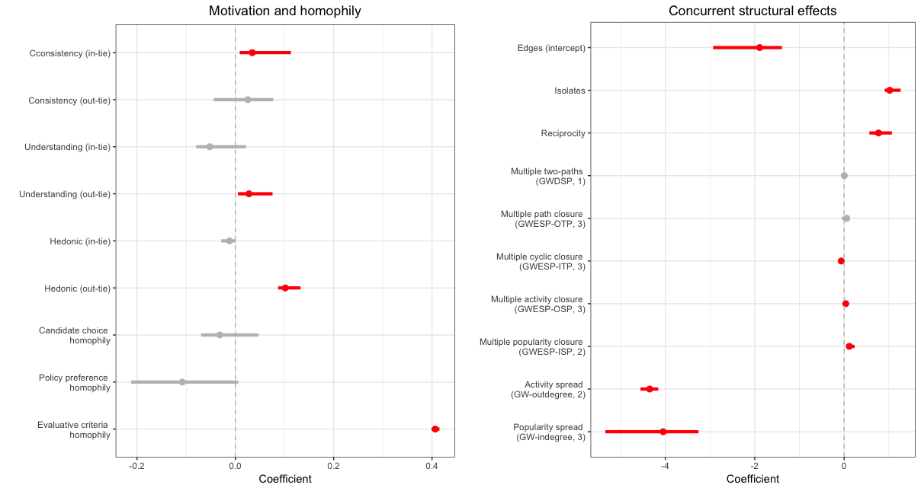

Note: Coefficients for key predictor variables (as reported in Table 2 in the main document) and their 95% CIs are reported (significant model terms are denoted in red).

# **Figure S2. Parameter estimates and 95% confidence intervals from the final model (con’d)**

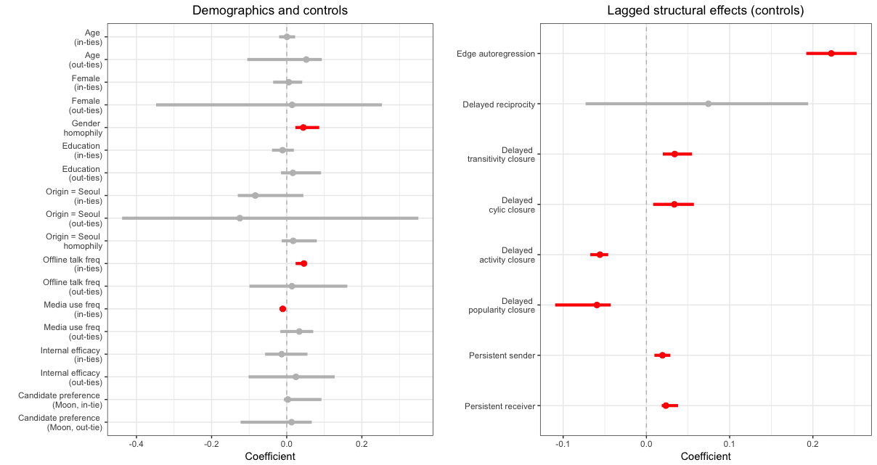

Note: Coefficients for control variables and their 95% CIs are reported (significant model terms are denoted in red).

# 

# **Table S4. Additional robustness checks**

Predicting “change statistics” of key network-endogenous variables as a function of *same candidate preference* and *similar policy preference*, using *netlm* (QAP-regression) and *netlogit* (QAP-logit regression)

|  |  |  |  |  |  |  |
| --- | --- | --- | --- | --- | --- | --- |
| **DV:** | **Popularity spread**  (gw-indegree) | | **Activity spread**  (gw-outdegree) | | **Reciprocity**  (mutual) | |
| ***IV: Same candidate preference*** | | | | | | |
| *Time point* | ***b*** | ***Pr* ≥ (|*b*|)** | ***b*** | ***Pr* ≥ (|*b*|)** | ***b*** | ***Pr* ≥ (|*b*|)** |
| *T = 1* | -.0056 | .257 | -.0122 | .089 | .1234 | .225 |
| *T = 2* | -.0024 | .750 | .0023 | .828 | .0716 | .662 |
| *T = 3* | -.0053 | .286 | -.0068 | .401 | .0934 | .530 |
| ***IV: Policy preference similarity*** | | | | | | |
| *Time point* | ***b*** | ***Pr* ≥ (|*b*|)** | ***b*** | ***Pr* ≥ (|*b*|)** | ***b*** | ***Pr* ≥ (|*b*|)** |
| *T = 1* | .0059 | .847 | .0804 | .010 | -.5281 | .405 |
| *T = 2* | .0564 | **.036** | .1355 | **.001** | -2.0456 | **.005** |
| *T = 3* | .0275 | .312 | .0394 | .347 | .3777 | .593 |

*Note*: *b* = unstandardized regression coefficients, where models include only intercept and a respective predictor variable. We used the double semi-partialing permutation with 1,000 replications for deriving probabilities of observed value (*b*) exceeding the either lower or upper tails of the simulated distribution at .05 level (denoted as *Pr* ≥ (|*b*|) above). Since change statistics for reciprocity is constrained to be zero and one, we used *netlogit* (logit regression QAP) instead of *netlm* (QAP regression). For all other dependent change statistics, we used *netlm*.